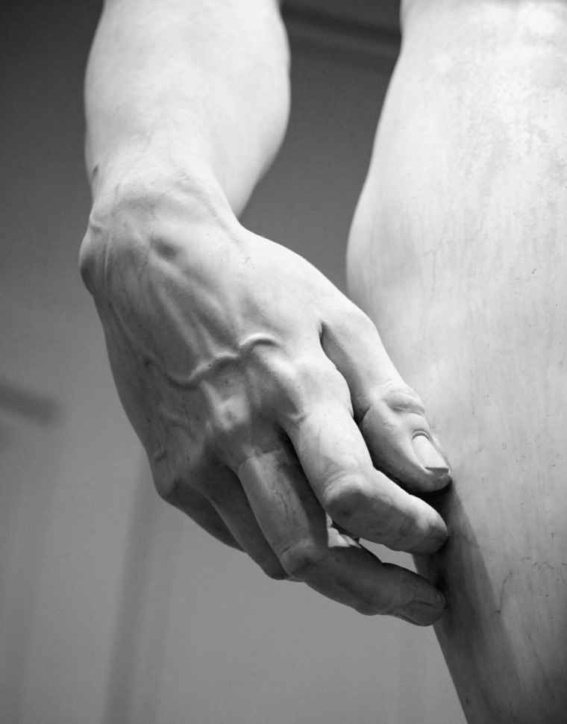
16th March 2022, Wednesday
Forearm and Hand Sculpture Course- Program
8.30am: Coffee and Registration
9.00am: Introduction to sculpting techniques- Francis Peart
9.30am: Anatomy of the forearm- Rajive Jose
10.00am: Sculpting workshop
11.00am: Coffee break
11.15: Sculpting workshop
13.00: Lunch
14.00: Nerve transfers in the forearm- Samuel George
14.30: Sculpting workshop
15.30: Coffee break
15.45: Sculpting workshop
17.00: Finish of the day and debriefing

17th March 2022, Thursday
8.30: Coffee
9.00: Introduction to sculpting techniques-Francis Peart
9.15: Anatomy of the wrist ligaments- Mike Craigen
10.00: Sculpting workshop
11.00: Coffee break
11.15: Sculpting workshop
13.00: Lunch
14.00: Anatomy of Extensor tendons: Ciara Deall
14.30: Sculpting workshop
15.30: Coffee break
15.45: Evolution of the human hand- Francis Peart
16.45: Quiz
17.45: Finish of the day.

18th March 2022, Friday
8.30: Coffee
9.00: Anatomy of Flexor tendons- Rajive Jose
9.30: Sculpting workshop
11.00: Coffee break
11.15: Sculpting workshop
13.00: Lunch
14.00: Anatomy of Nerves of upper limb: Simon Tan
14.30: Sculpting workshop
15.30: Coffee break
15.45: Clinical problem solving
17.30: Prize giving
17.45: Finish of the day.

