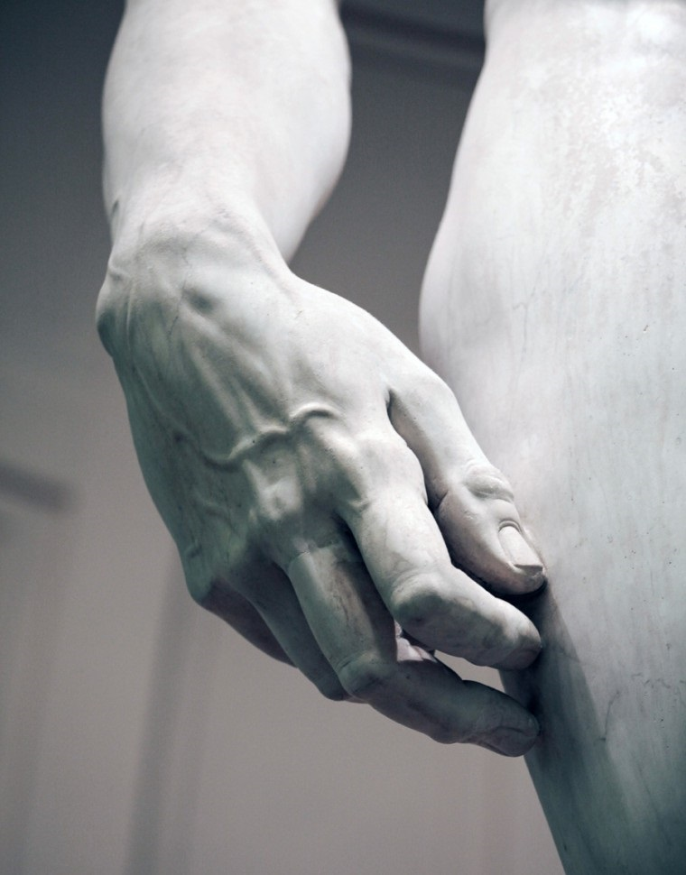
Hand Sculpture Course- Work book

Day 1

Sculpting materials
- Familiarise with the materials you are using
- Wax
- Sculpting tools
- Oil colours

Anatomy of the bones of hand and wrist

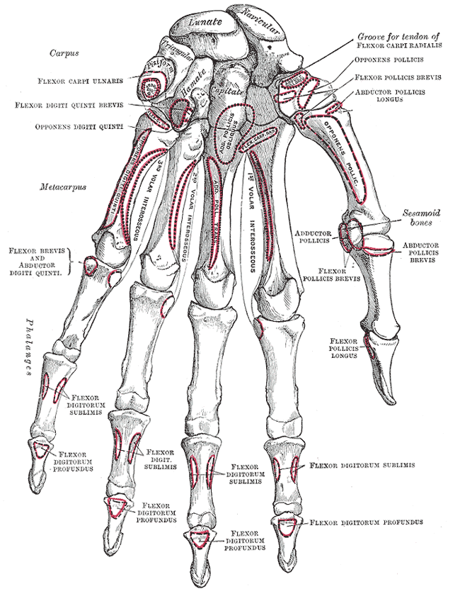
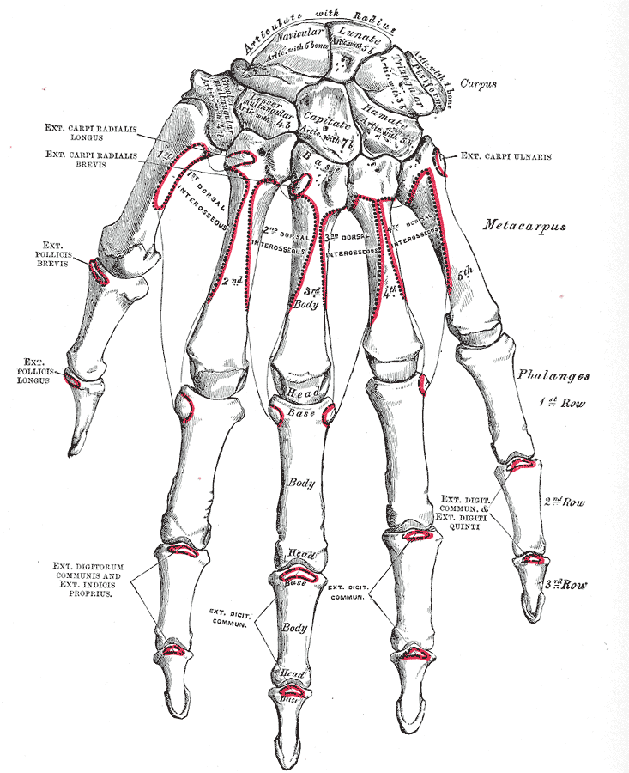

Ligaments of hand and wrist

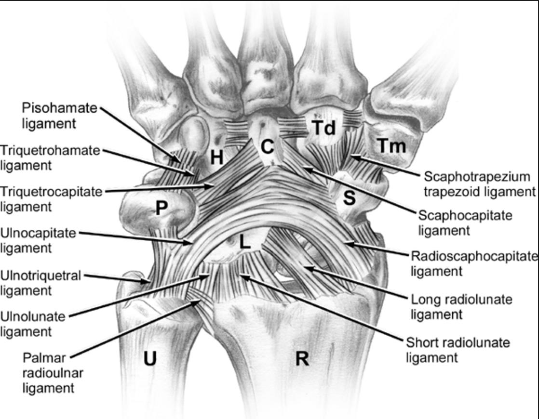

Volar aspect

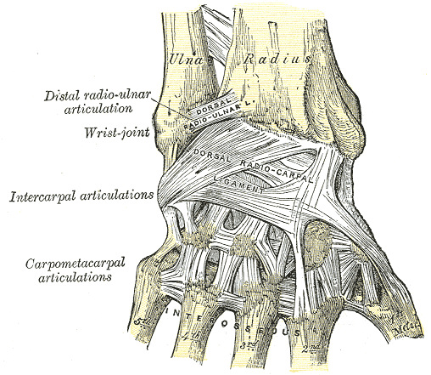

Dorsal aspect

Fingers

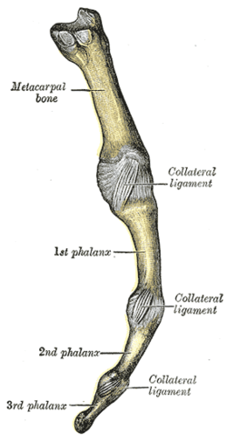

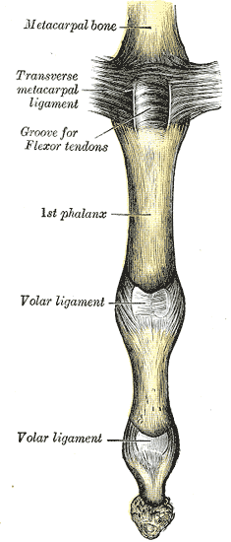

Practical session 1:
Creating the ligaments

- Volar wrist ligaments.
Using rolled and flattened wax create the following extrinsic ligaments using the illustrations as a guide.
- Radioscaphocapitate ligament
- Long radiolunate ligament
- Short radiolunate ligament
- Ulnolunate ligament
- Ulnocapitate ligament
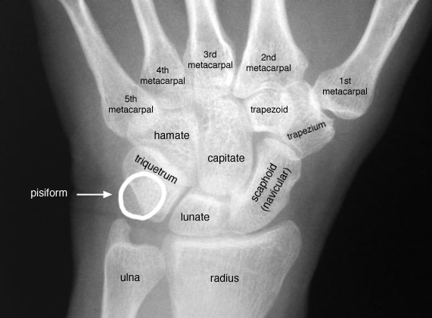
- Ulnotriquetral ligament

Appreciate the space of Poirier between the two chevrons.
You can make the ligaments appear more real using finer sculpting tools and colour them using oil paint. The conventional colour is green

- Dorsal wrist ligaments

Using rolled and flattened wax create the following extrinsic ligaments using the illustrations as a guide.

- Dorsal radiocarpal ligament
- Dorsal intercarpal ligament

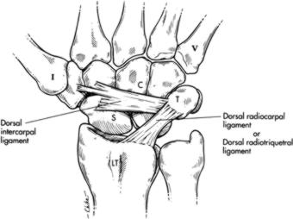

- Beak ligament of thumb.
Create a ligament between the ‘trapezium and beak’ of first metacarpal.

- Radial and Ulnar collateral ligament of thumb and other finger MCP joints.
Appreciate the orientation of these ligaments with the proximal volar attachment.

- Radial and ulnar collateral ligaments of the interphalangeal joints.
Appreciate the difference in shape of the metacarpal head and the head of the proximal phalanx change. This is the reason for the change in length of the collateral ligaments with MCP flexion and the reason for the intrinsic position of the hand.

- Create the volar plates for the MCP and IP joints.

Colour these ligaments using green.

Dorsal interossei

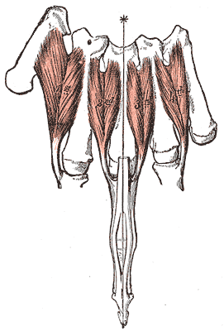

Palmar interossei
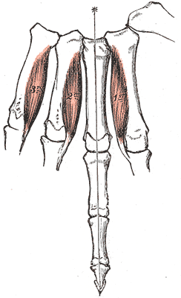

Thenar and hypothenar muscles

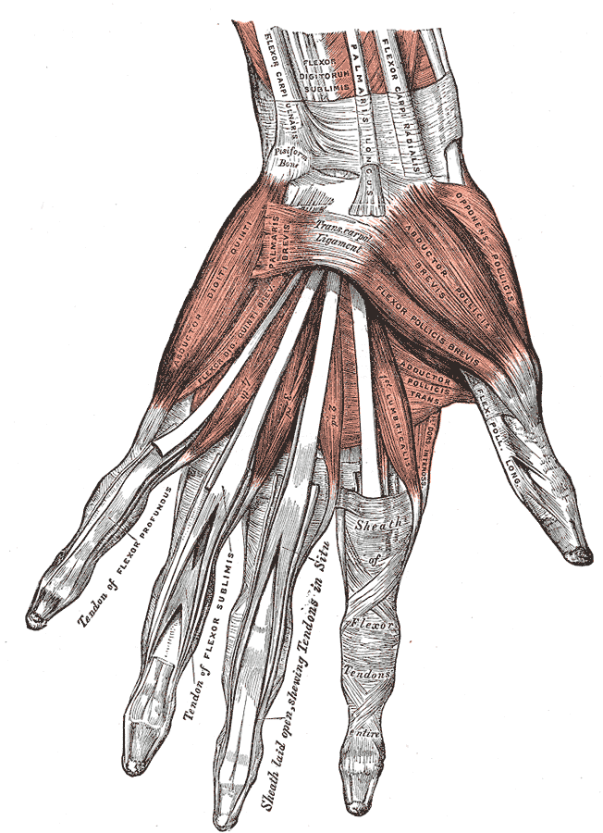

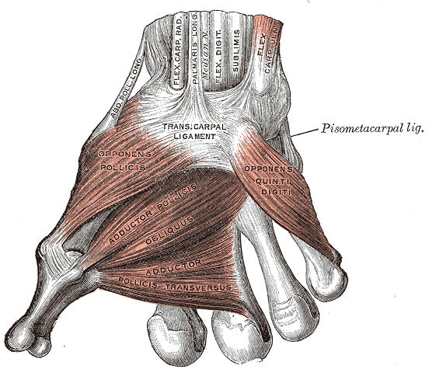
Extensor tendons

Practical session 2:
Creating small muscles of the hand

- Using the picture, create the dorsal interossei. These are bipennate muscles taking origin from both the metacarpals. They are attached to the base of the proximal phalanx and the extensor tendon. AS you have not completed the extensor tendon you can complete the distal part later.
- Create the palmar interossei. These are unipennate muscles which take origin from one metacarpal only.
- Create the thenar and hypothenar muscles.
Make adductor pollicis noting its origin from the third metacarpal and create its aponeurosis which goes over the ulnar collateral ligament of the thumb. Remember how this can be the cause for the Stener lesion.
Remember that abductor pollicis brevis and flexor pollicis brevis take origin from the flexor retinaculum, so you can make them after you make the flexor retinaculum on the second day.

Make the muscles look more real by creating the fibres using sculpting tools. Colour the muscles brown.

Extensor tendons of the hand and wrist

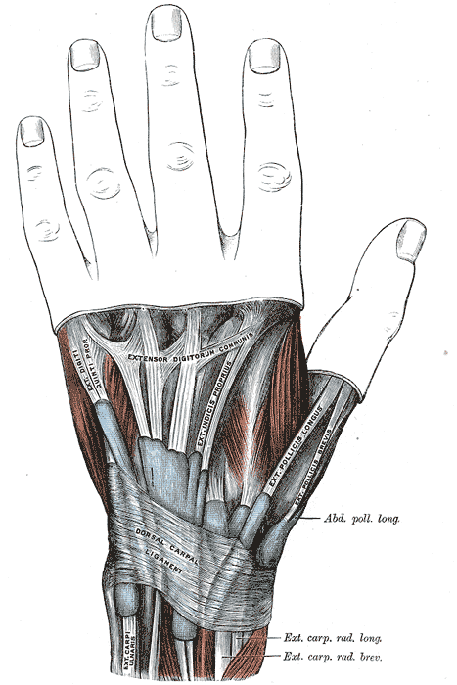

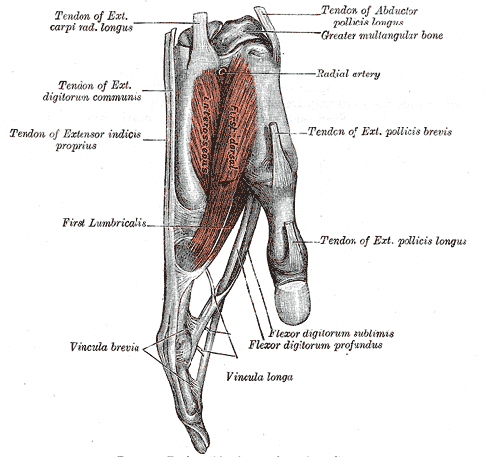

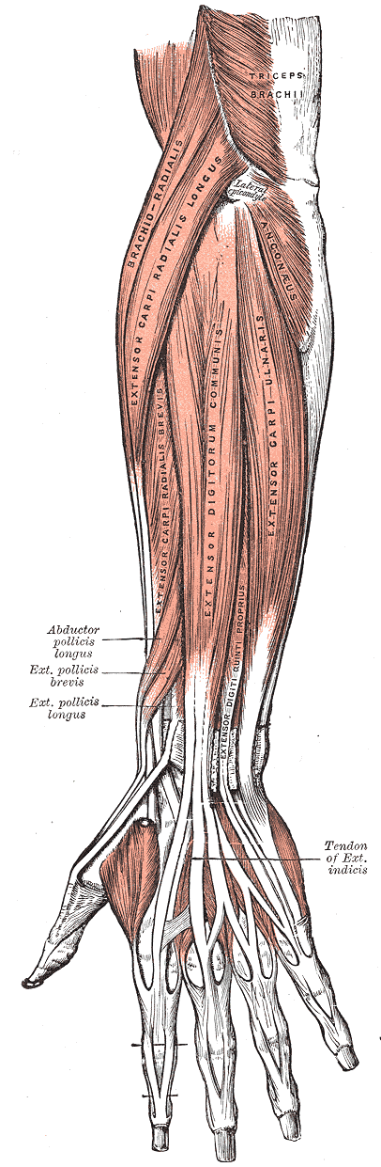

Practical Sessions 3:
Creating the Extensor tendons
You will find premade strips of wax which you can use for creating your tendons. Alternatively, you can make your own tendon strips.
Remember the compartments of extensor tendons and try and make them in order.
Make them up to the MCP joints and create the sagittal bands. Create the juncturae tendinum between them. Appreciate the arrangements between EIP and EDC and EDM and EDC.
Using flat sheets of wax create the extensor retinaculum.
Now complete the distal extensor mechanism creating the central slips and lateral bands. You can now connect your interossei to the extensor mechanism.
Try and create the radial artery in the anatomical snuff box, as it passes between the two heads of first dorsal interosseous muscle.
If you have time, create the cutaneous nerves, superficial radial nerve and the dorsal branch of ulnar nerve.
Now is the time to make the inter-metacarpal ligaments. Turn the hand and create them between the metacarpal heads. Remember that they are volar to the interossei.

Day 2
Flexor tendons

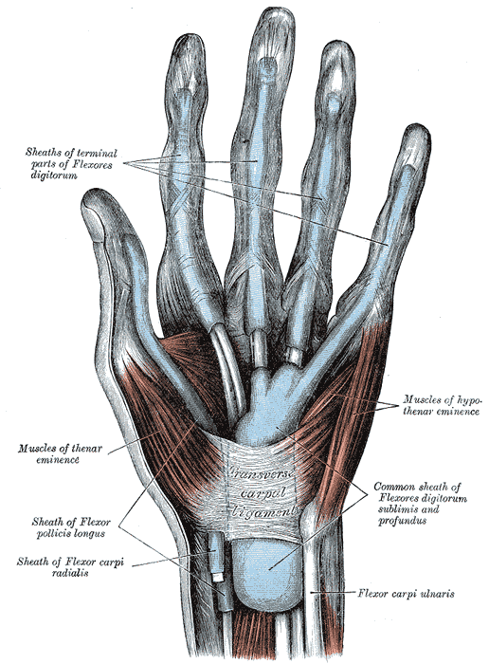

Practical session 4
Creating the flexor tendons.
Using the pre-made tendons, create FDS and FDPs of the fingers. Make note of the chiasma of the FDS and how the FDP tendons pass through them.
Create FPL for the thumb.
Now create the pulleys. Create A1 pulley, oblique pulley and A2 pulley for thumb. Create A1-A5 and the cruciate pulleys for the fingers.

Median, ulnar nerves

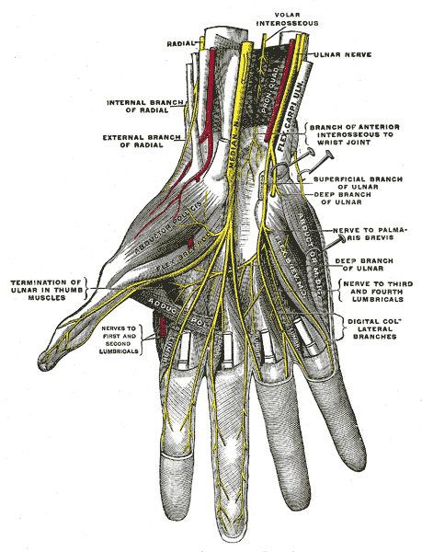

Practical session 5
Create the median and ulnar nerves and the digital nerve branches. Colour them yellow. Try and create the motor nerve branches to thenar muscles.

Palmar arch
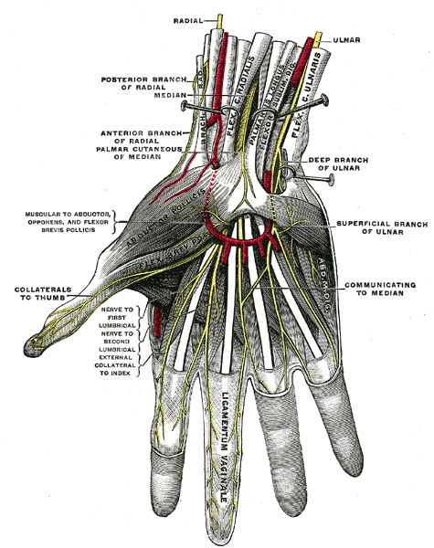

Practical session 6
Create the arteries to the hand. Note how the radial artery passes into the palm between the two heads of dorsal interossei. Complete the palmar arch and the digital vessels.
Now complete the flexor retinaculum and the rest of the thenar muscles.
If you have time, you can complete the hand into a life-like model using the surface anatomy pictures

Surface anatomy of the hand

