HANDBOOK

FACIAL CONSTRUCTION COURSE 18, 19 and 20 September 2019

INTRODUCTION

This course is designed as a creative exercise in facial soft tissue anatomical appreciation. Over three days, each candidate will be engaged in layering the soft tissue anatomy over a mounted skull template. The course is structured so as to allow for an accurate and systematic modeling, such that the full three-dimensional anatomy can be both appreciated and internalized in memory.

DAY 1

After a short introductory lecture on the materials and tools, the facial sensory nerves will be constructed, after which the eyes will be positioned within the orbits with their surrounding supportive tissue framework.
This is followed by the placement of the deepest facial muscular layer, incorporating the masseter, temporalis and buccinators muscles. The next structure to be created is the nose with its cartilaginous framework, followed by the mouth and its surrounding muscles. Time is allocated to the placement of the facial nerve and vessels, with the investing parotid gland. The further structure requiring construction are the periorbital muscles and frontalis, and finally the external ears.
It is suggested that one half of the skull is invested with skin, and modelled so as to be as lifelike as possible, with special attention to facial character and aging.

SENSORY NERVES

The first exercise in the anatomical construction will be to create the sensory nerves that emanate from their various skull orifices- in particular the trochlear and supraorbital nerves, and the infrorbital, mental and nasal nerves. These will need to hand free until such time as the facial musculature has been completed, and their ultimate destination will be the skin. It would be worth considering adding two vessels groups- the trochlear and supra-orbital, to the nerves as they emanate from the orbit off the internal carotid system, and should ideally be placed before the orbital structures are created.

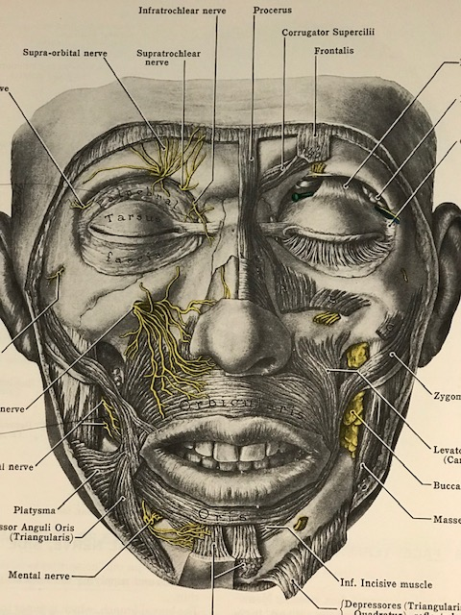
EYES

The eyes are then fixed within the orbital cavity with wax, round these are placed the superior and inferior supportive fat compartments. This is followed by the construction of the tarsal plates and their medial and lateral canthal attachments, with connections with the levator muscle as an aponeurosis. Again, accurate placement is essential if a normal looking eye is to be created. It will be important to place the globes symmetrically in all dimensions- avoiding enopthalmos, proptosis, squint, and dystopia. Thereafter the fat compartments that support the globes will be created, the understanding of which is essential for an understanding of facial aging, and any form of periorbital surgery.
will be given to avoiding proptosis, lagopthalmos, and lower lid ectropion.

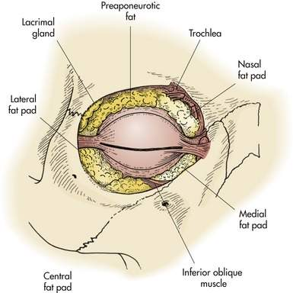
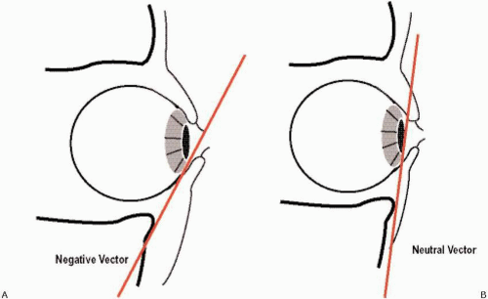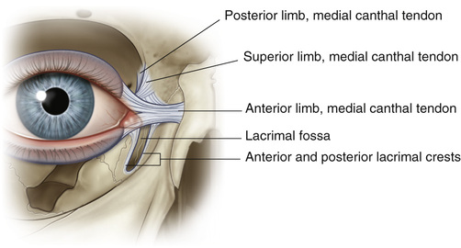

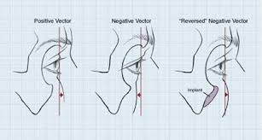

THE DEEP FACIAL MUSCLES

Temporalis
These powerful muscles responsible much of our bite force, originating from a contoured easily discernible lateral skull recess (at the temples, hence temporalis) and attached onto a mandibular projection called the coronoid process. In some creatures the muscles are sufficiently large so as to meet in the midline at a temporal crest ( in the hominin called “the nutcracker man”). It provides a readily discernable lateral contour to the face, which recesses with age and is an indicator of facial aging. It is innervated by the fifth cranial nerve.

Masseter
This is an additional muscle responsible for bite force, which has its origin over much of the laminar plate of the mandible, with attachment onto the pterygoid projection off the skull. Like temporalis, it provides contour to the lateral face, and is innervated by the fifth cranial nerve.

Buccinator

Innervated by the 7th cranial nerve, this muscle is arguably a muscle of facial expression. This elastic sheet of contractile tissue has its role in eating is to facilitate deglutition, by proving both oral capacity and thereafter propulsion, and maintaining oral continence. However it has a role in facial animation as well. Its attachment is to the maxilla and mandible.

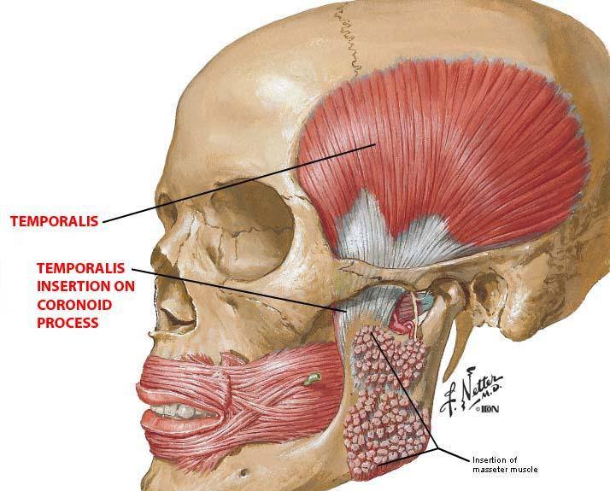

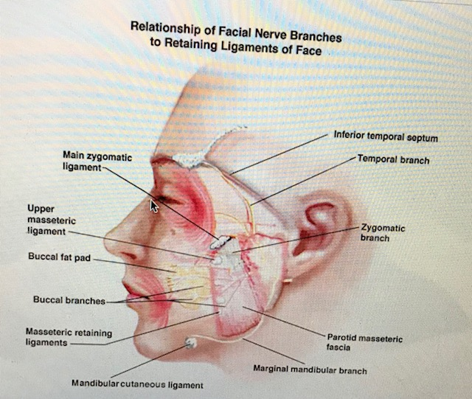

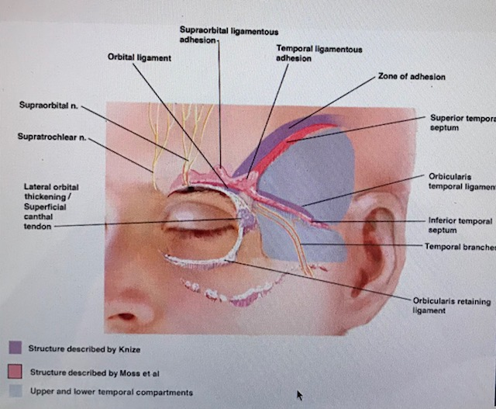

FACIAL VESSELS ( MAJOR ARTERIES AND VEINS)
This will be the fourth exercise after the sensory nerves, orbital structures and deep facial musculature have been created. It must be appreciated that these vessels, which effectively lie on the deep muscles, will ultimately ramify variably amongst the more superficial musculature.
The principle facial vessels are the facial and the superficial temporal artery and vein. The arteries both branching off the external carotid artery, and it is worth considering the building of a stump of external carotid as an anchoring point. The facial vessels will branch into the perioral (superior and inferior vessels), the nasolabial vessels, and finally the nasal vessels. The superficial temporal artery provides a post auricular (posteriorly oriented) branch and a zygomatic branch (anteriorly oriented). It then ramifies from and anterior and posterior branch over the temporal area. A periorbital vessel system (with its superior and inferior arcades) could also be created, anastomosing with the facial and superficial temporal systems.

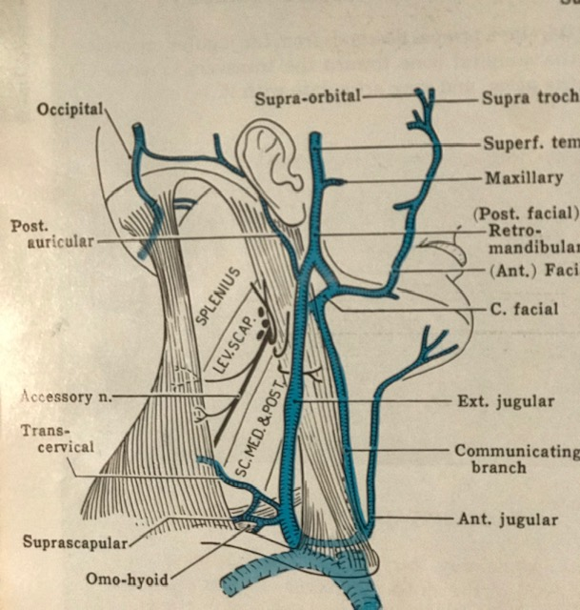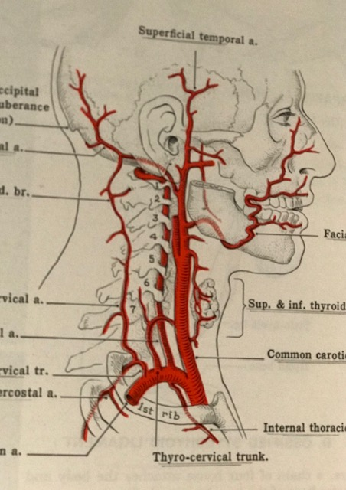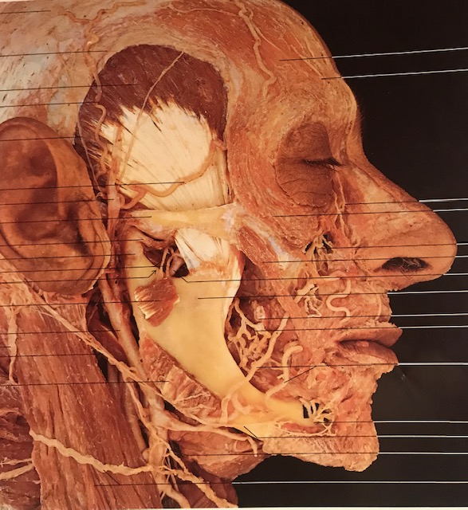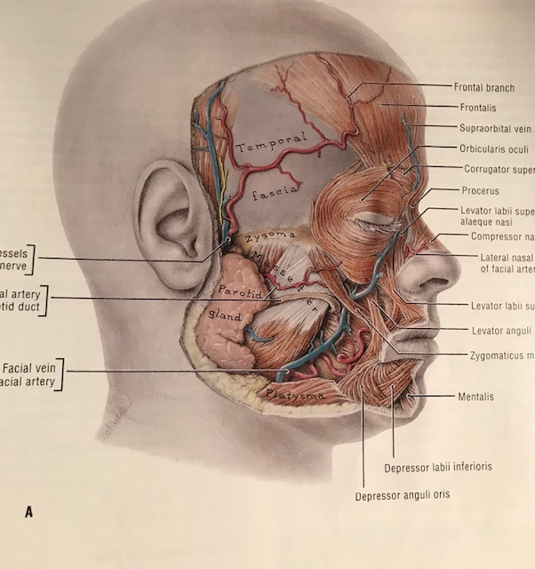

THE MOUTH AND PERIORAL MUSCLES

The placement of the mouth over the teeth provides a foundation to which the motor muscles controlling the mouth can be attached.
The sculpting of the mouth required an appreciation of mouth contours, all the result of the interweaving of orbicularis oris muscles, fat compartments and the overlying vermilion. The philtrum, white roll, tubercle and mouth angles must be created. The mouth angles meet at a fibrous tissue consolidation called the modiolus or anchor.
There are 9 periocular muscles that need to be considered on each side- nasalis, levator labii suerioiris alaequi naris, zygomaticus minor and major, levator anguli oris, risorius, depressor anguli oris, depressor labii inferioris, and mentalis.
All of these muscles are innervated by the 7th cranial nerve, and play a critical role in facial expression and speech, and in eating.
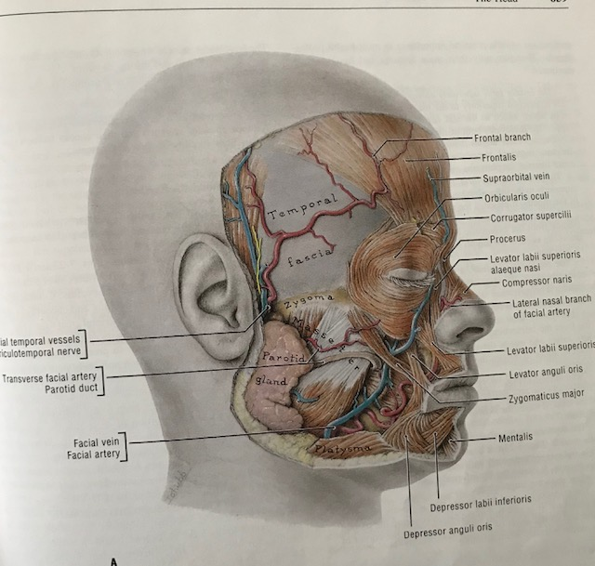

DEEP FAT COMPARTMENTS
The buccal fat pad now requires construction, being placed in the space between the buccinators and the masseter and ramus of the jaw, extending within the spaces between the facial muscles of expression in the cheeks. It extends superiorly under the zygomatic arch into the temporal recess above the temporalis muscle. It is of variable size and provides contour to the cheek.

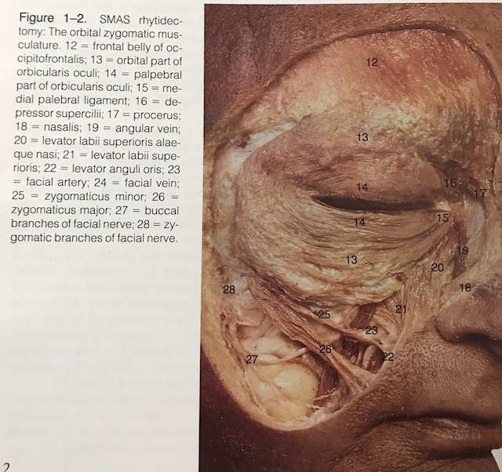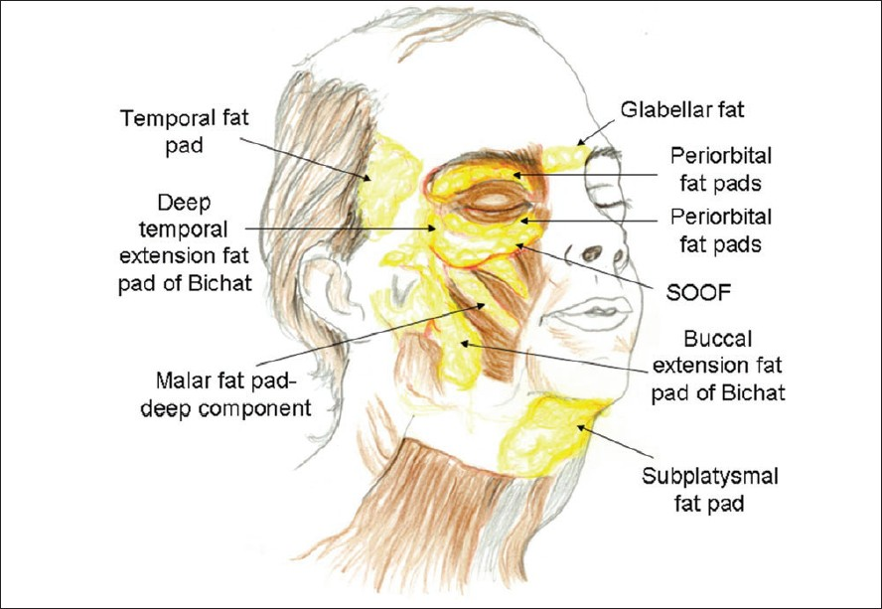

THE PAROTID GLAND AND FACIAL NERVE

The parotid gland now required construction, along with the prefabricated facial nerve. The parotid gland is placed over the masseter muscle, in fact lying on the fascial sheet called the masseteric fascia, and is itself invested in fascia (parotid fascia). Within its substance, and separating the deep from the superficial glandular elements, is the facial nerve with its multiple branches. The parotid duct courses over the anterior edge of the masseter muscle, a fingers breadth below the zygomatic arch, and then exits through the buccinator muscle and oral mucosa into the mouth opposite the first molar upper.
The facial nerve emanates from the stylomastoid foramen, and plunges into the parotid gland, within which it ramifies into five basic elements- temporal or frontal, zygomatic, buccal, mandibular, and cervical. The nerve supplies the muscles on their deep surfaces, except when the muscles are two layers thick, in which case the deeper muscle is supplied superficially (buccinators, LAA).
It emerges from the substance of the parotid at its anterior margin near the masseter anterior edge, from which the nerves element course to their effector muscles.

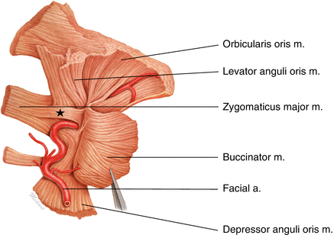
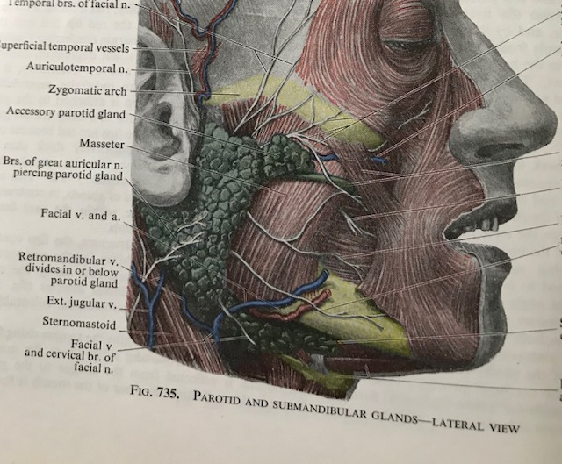

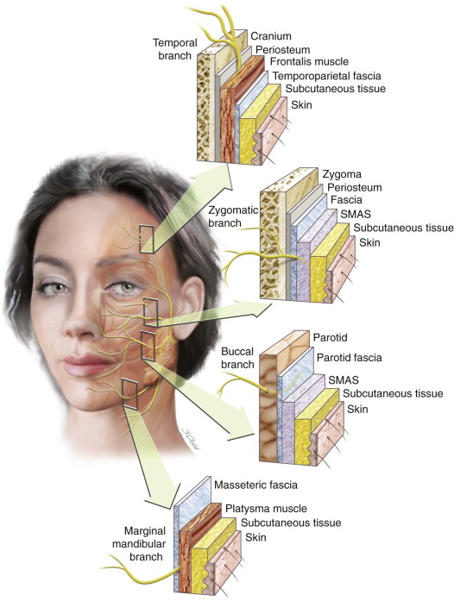

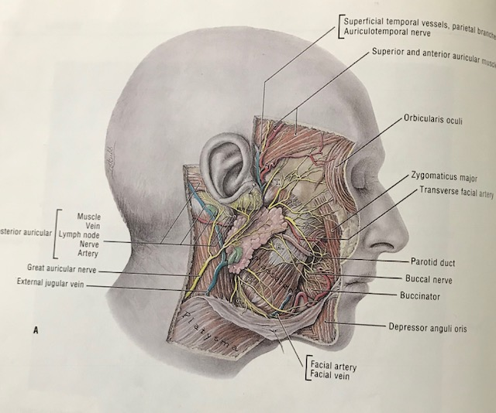

DAY 2

PERIORBITAL MUSCLES

The orbicularis oculi muscle is a sheet of muscles covering the eye, underlying which is the levator supercilii, responsible for glabellar frown lines. Its subtle attachments are shown in the diagram.
It has a close relationship with the frontalis muscle. Being muscles of facial expression, they are innervated by the 7th cranial nerve.

NOSE

The construction of the upper cartilaginous nasal vault involves the placement of the nasal septum within the piriform aperture, with its posterior attachment to the bony septum, and then the creation of the bilateral upper lateral cartilages. This is followed by the moulding of two lower lateral cartilages, which are individually contoured to giver the nose its individual shape. On one side, what is effectively a sheet of muscles can be placed over the nose, to include procerus, levator naris, levator labii superioris alaequae naris, nasalis and depressor septi.

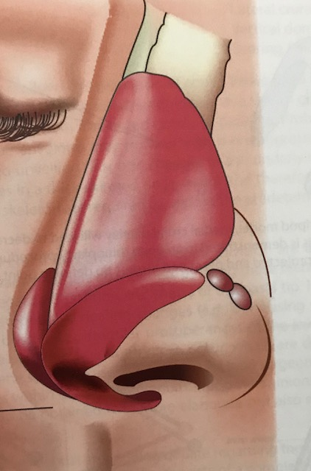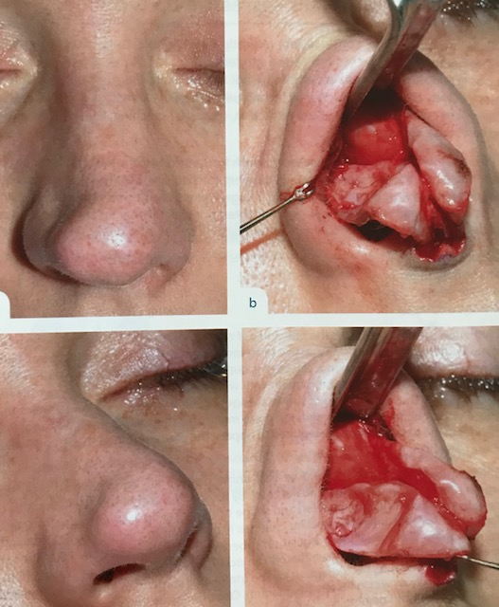

THE EAR

One of the peculiar features of mammals is the presence of an external ear. In humans, this has a characteristic shape, with defined and named contours. It is believed that these contours act to enhance appreciation of sound frequencies within the range of human vocalization.
The specific contours to create are the concha, helix, antihelix, tragus and antitragus, and lobe.

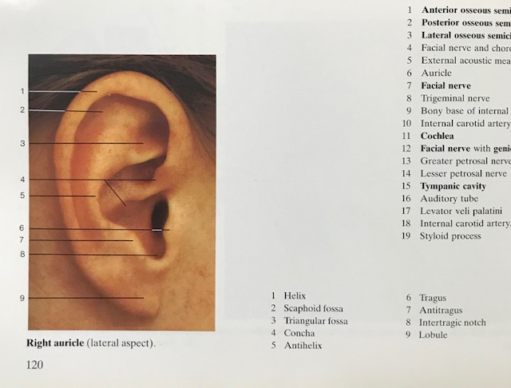

SUBCUTANEOUS FAT AND SKIN

Efforts have been made to understand how subcutaneous fat is distributed over the face, giving it its characteristic individuality, and providing an understanding of how the face ages. The various compartments are shown in the following diagram. For those who wish to create a complete face, putting on the final layer of the face- the skin and subcutaneous tissue, the appreciation of the fat compartments will aid in achieving a likeness vitality and realistic portrayal.

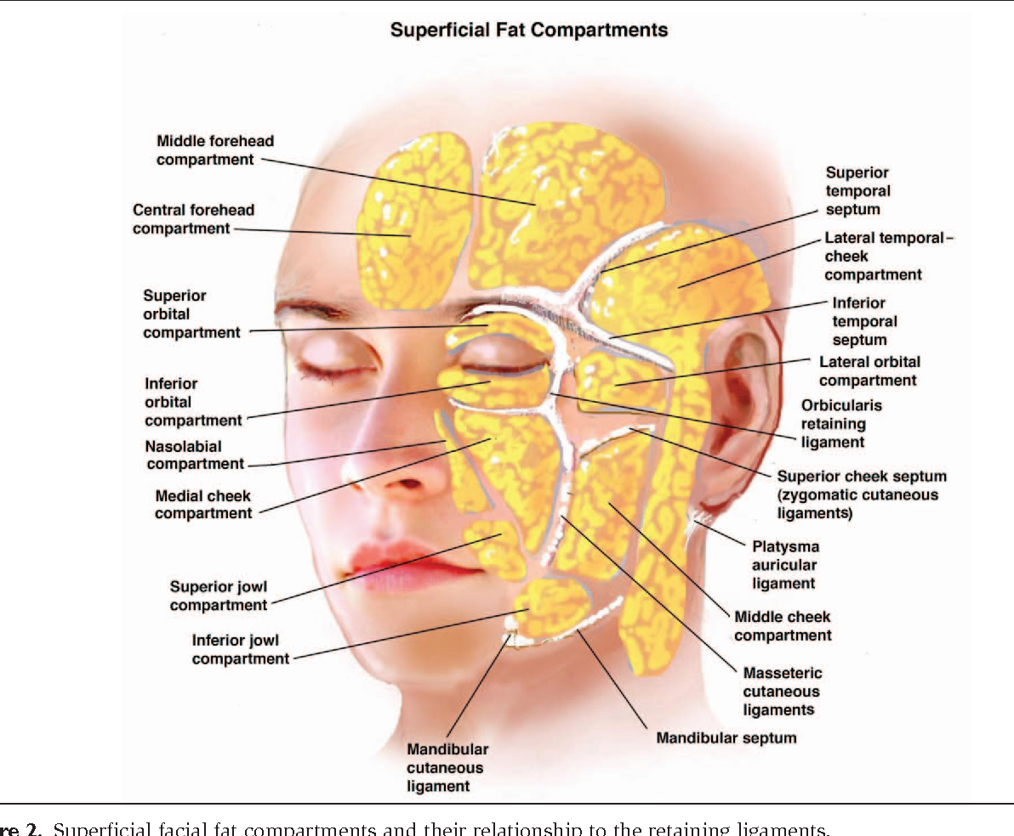

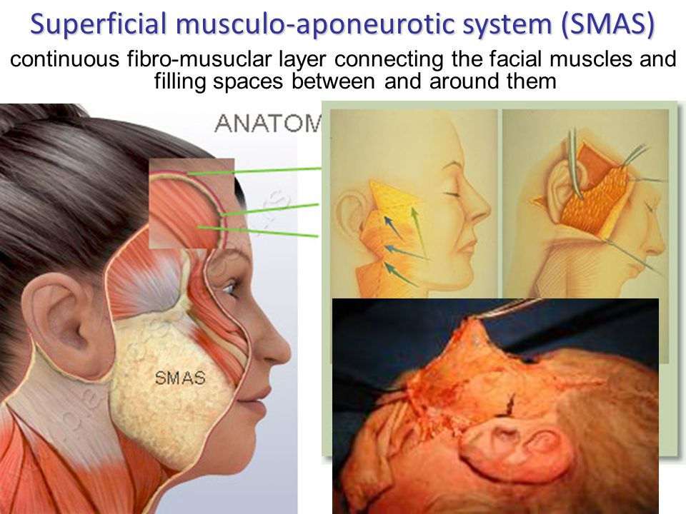

DAY 3

The day will start with lectures on facial character, aging and aesthetics. A sculptured model will be constructed on one half of the skull, with a live model present. Tinted wax, and hair will allow for the most realistic portrayal possible.

The afternoon session starts with a final lecture on facial origins, and judging by the faculty on which sculpture is the courses’ best. For this, a prize will be awarded.

